

**OE4080**

Froude Krylov Force

**Subodh Wasnik Roll No.: NA18B116**

**Department of Ocean Engineering**

# Summary

This report compares the results of ANSYS AQWA with those of the MATLAB code or the Froude Krylov Force operating on a floating structure.

# Froude Krylov Force

The pressure distribution on the faces of the submerged section of the floating construction is used to compute the Froude-Krylov force. On a fairly sized structure, the Froude-Krylov force provides an acceptable approximation of approximate force.

Because of the formula's simplicity, it may be used to calculate force on a wide range of complicated structures.

The following equations can be used to compute the horizontal $F_{x}$ and vertical $F_{y}$ components of the Froude Krylov force $F$:

$$F_{x}=C_{H}\iint_{S}{p∙n_{x}dS}$$

$$F_{z}=C_{V}\iint_{S}{p∙n_{z}dS}$$

Where,

$p$ is the instantons normal pressure.

$S$ is the total submerged area.

$C_{H}$ and $C_{V}$ are the constants for horizontal and vertical components Froude Krylov force respectively.

Because the assumed wavelength is substantially larger than the primary dimension, diameter $D$, we may assume that the force is solely operating in the horizontal direction, i.e. $x$. As a result, the equation for the Froude-Krylov force is simplified to

$$F=\frac{pπD^{2}\dot{u}}{4}$$

# MATLAB

The aforementioned force is implemented in MATLAB. The MATLAB function used to obtain the Froude Krylov MATLAB results can be viewed in

*H* , *T* , *k* , *w* are wave height, time period, wave number, and angular frequency respectively.

# Wheeler’s Stretching

In Wheeler's Stretching, the distribution down to the seabed is stretched by the kinematics produced by the Airy Wave Theory at the mean water level and applied to the true water

level. Substitute the vertical coordinate *z* with

*z* ' , where

*z* ' is determined by:

where  is the free surface elevation.

# Force Estimation

*z* '   *z*  

*d*

*d* 

The algorithm used to estimate the force experienced by the cylindrical structure placed in water with regular waves and known parameters is explained below.

1. Divide the waves into *n* time steps.
2. Divide the submerged structure into sub-segments.
3. Apply the Morison Equation with appropriate kinematics to estimate the force per unit length at each of the sub-segment.
4. To determine the force at this specific time step, perform numerical integration of the determining force on all the sub-segments according to certain accepted rules.
5. Repeat the above steps for each time step to get the force-time data.

The algorithm was implemented in MATLAB and the code can be accessed [here](https://drive.google.com/drive/folders/1i1a6rR6hqXkSPt_8UTvaXqwMvv5IQgqj?usp=sharing).

# Results

Using the algorithm described above, the forces on two different cylindrical constructions for a given input regular wave were calculated. The following were used as the wave parameters and sea depth inputs:

* *H*  18 m
* *T* 14 s
* *d*  85 m
* *L*  85 m

1. Mass dominated structure

*D*  5 m

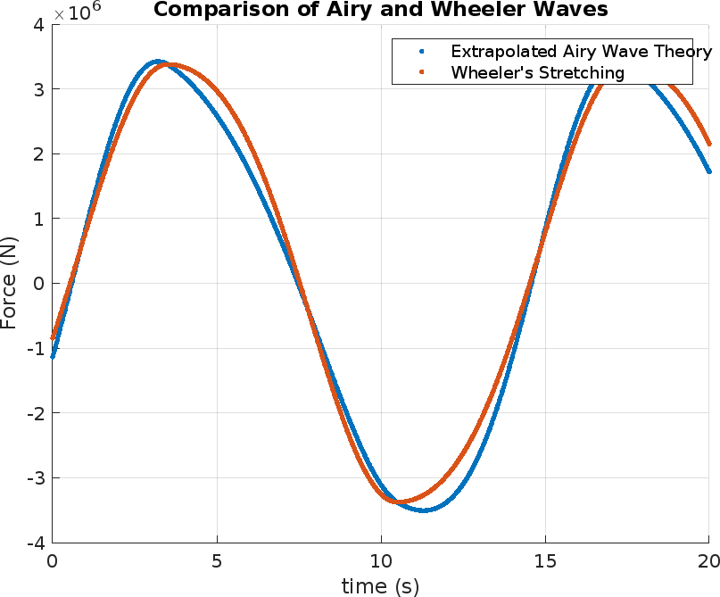

1. Drag dominated structure

*D*  0.5 m

